
CS 319 - Object-Oriented Software Engineering
Design Report
Hallway Rush
Group D
Caner Bozkurt
Doga Dikbayir
Ezgi Ebren
Mert Uygur

\
Table of Contents
1. Introduction 3
1.1. Purpose of the system 3
1.2. Design Goals 3
1.2.1. Trade Offs 4
2. Software Architecture 4
2.1. Subsystem Decomposition 4
2.2. Hardware/Software Mapping 6
2.3. Data Management 6
2.4. Accessibility and Security 6
2.5. Boundary Conditions 6
2.5.1. Initialization 6
2.5.2. Termination 7
2.5.3. Failure 7
3. Subsystem Services 7
4. Low-level design 9
4.1. Object Design trade-offs 9
4.2. Packages 9
4.2.1. Game Core 9
4.2.2. GUI Design 17
4.3. Class Interfaces 18
5. Glossary & references 19

Introduction

Purpose of the system
Hallway Rush’s game system aims for player to have fun without worrying about complicated HUD (heads-up display) that confuses player. The game’s user interface is going to be implemented with simplistic manner that does not interrupt player with unnecessary buttons or screens. This allows players to simply focus the game and try to beat the high score.

Design Goals
Hallway rush’s is going to be implemented with latest Java Development Kit. Hallway Rush will take full advantage of Java; game will be platform independent, lightweight and robust.

Adaptability: One of the most significant advantages of Java is its ability to move easily from one computer system to another. The ability to run the same program on many different systems is crucial to World Wide Web software, and Java succeeds at this by being platform-independent at both the source and binary levels.

Efficiency: Gameplay of The Hallway Rush will be fluid and responsive since the main purpose of the video gaming is creating smooth images that entertain players. Thus, we are going to implement the game such that memory will be allocated efficiently to improve performance. Also Java is self-garbage collecting programming language, therefore memory leaks of the game will be minimal.

Reliability: The Game will be implemented using object-orientation principle, which includes encapsulation. Encapsulation will make the game error free and robust since inner parts of the game that shouldn’t be changed by user will be protected.
Extendibility: Since the game is implemented with object-oriented principle after the first version of the game implemented, game can be further improved by adding additional object classes.

Trade Offs
Functionality vs. Usability: Since Hallway Rush aims for an easy game-play, usability will have priority over functionality. This means, the game will only have fundamental functionalities such as quitting the game and keeping high score.
Efficiency vs. Memory: The game will use minimal memory by keeping the graphics or effects simple so that we can provide high-performance with smooth transitions.

Software Architecture

Subsystem Decomposition
The overall system will consist of subsystems in order to provide modularity and reduce complexity of the design. The three-tier architecture is adapted when decomposing the system into subsystems.
In the User Interface level there is the HRInterface subsystem, which will contain GUI components like menus. The user will be able to interact with these components in order to communicate with the game. The user’s inputs will be collected at this layer and will be sent to the next layer, Game Core & Logic. This layer contains controller subsystems, which take inputs collected by the HRInterface subsystem and process them in order to run the game properly. At this stage, the SettingsManagement subsystem plays a crucial role on handling game’s settings. The user will interact with the settings menu in the HRInterface subsystem and the raw parameters will be passed to the InputManagement subsystem. This component will process the raw input data and send it to the SettingsManagement subsystem. The subsystem will communicate with the GameManagement subsystem in order to set the games with the provided options. The inputs received during the game will again be collected by the HRInterface component and the raw input data will be processed by the InputManagement subsystem. Unlike the settings management process, this dynamic input data will be directly sent to the GameManagement subsystem in order to run the game.
Finally, to store high score data, the HighscoreManagement subsystem in the Game Core & Logic layer sends data to the HighscoreStorage subsystem located at the Storage layer.
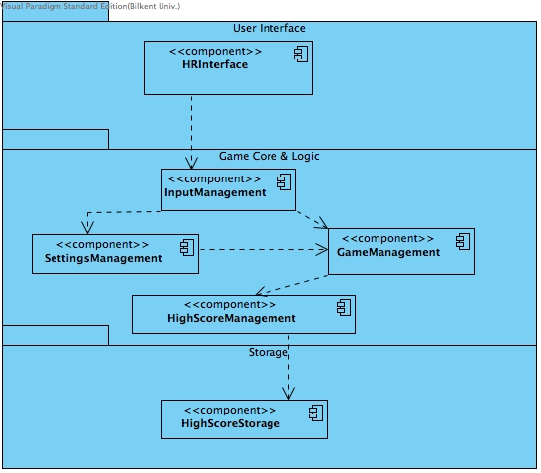
Figure 1- Subsystem Decomposition shown using UML component diagram (layers are shown as UML packages)

Hardware/Software Mapping
Hallway Rush is going to be implemented in Java programming language. The game needs keyboard in order to take inputs from player. Since we will implement the game in Java and system requirements are going to be minimal, a computer with software installed such as an operating system and Java Virtual Machine that runs java associated programs. Also, we will benefit from java’s platform independency; therefore game will run on most operating systems.
As the system decomposition shows there is Game Core & Logic layer that includes InputManagement subsystem. InputManagement serves as a bridge between hardware and software.

Data Management
Our game will only store high-score data in the computer’s hard disk. The high score data will have a format in order to allow the HighscoreManagement subsystem parse it and use it properly in the system. The formatted high score data will be stored in a text file and the system will read from it and write to it when it is necessary.

Accessibility and Security
Hallway Rush is designed to be a single player game. Therefore there are not any network security protocols to be handled by the system. The game does also not have a user database so there are no authentication credentials to be secured by the system. The only concern at this stage may be accessibility, which could corrupt the system’s data and cause problems in the runtime. So the accessibility to the core system files should be limited. However this limit should not prevent the user from experimenting on the game to a certain level.

Boundary Conditions

Initialization
Hallway Rush does not have an executable file so it does not require installation. It is executed as a simple .jar file.

Termination
Termination of Hallway Rush occurs in these cases:
- If the player decides to quit before, during or after the game; they can terminate by clicking the “x” button on the upper right corner of the game panel, or by choosing “quit game” option from the main menu.
- If a failure occurs during the game which requires termination and fixes.

Failure
If any of the files used in the game are corrupted at any point before the initialization or during the execution of the game, the game will be terminated with an error message and corrupted data will be fixed. However, minor errors in performance will not result in termination. Instead, the user will be informed about the nature of the problem and advised to re-initialize.

Subsystem Services
In this section further information about every subsystem introduced before will be given at the system design level. The details about the classes used by the subsystems will be introduced and explained in the object design phase.

HRInterface: This subsystem will display the user interface to the player and collect the raw input data from the user in order to send it to the Game Logic layer. The subsystem will consist of GUI components. Below the services provided by the subsystem are listed with short descriptions:
- Play Game: A new game is initialized with the settings handled by the SettingsManagement subsystem.
- Change Settings: The settings menu is displayed in order to let the player communicate with the SettingsManagement subsystem.
- Display High Scores: The high scores page is displayed
- Display Credits: Credits page is displayed
InputManagement: This subsystem will process the raw input data collected by the HRInterface and pass it to the other control subsystems. The InputManager class will serve this purpose using event listeners.
SettingsManagement: This subsystem will set the system’s settings variables to parameters passed by the user through HRInterface and InputManagement subsystems.
The services this subsystem provides, map the options in the settings menu:
- Change character’s gender: The subsystem will set the image file’s link associated with the character’s gender according to the input passed by the player
- Turn music on/off: The subsystem will set the associated boolean variable according to player’s choice
- Change ambient: The subsystem will set the background image file’s link according to player’s input
- Change game mod: The subsystem will set the game mod variable to standard/god/hardcore according to user’s choice
GameManagement: This subsystem contains the most important services in the system which determine the gameplay. This component is in concurrent communication with the InputManagement subsystem to process player’s input through the GameEngine:
- Game Engine: This service is the core of the program. It performs all the logical operations in the game with the parameters passed by other subsystems and it runs the game loop.
- Game Panel: This service visualizes the changes made by the game engine on game objects and the game map.
- Game Elements: This service will declare the game components and interact with the game engine
HighScoreManagement: This subsystem is basicallay responsible from determining which score is a high score and which high score will be recorded with a gold medal.
- High Score Manager: This service will take information from the game engine such as the score and if the boss is beaten. It will also collect player’s nickname. Finally it will format and send the formatted data to the storage layer.
HighscoreStorage: This subsystem is located at the storage layer of the system architecture. It is responsible from storing formatted high score data in a text file.
- High Score File: This service will be designed as a class which contains information to initiate the high score file and parse data from it in order to display it on the game screen.

The subsystem services are introduced and explained at this system design phase. Further information about the actual Java classes, which are going to be used in the services, will be introduced and explained at object design phase later.

Low-level design

Object Design trade-offs
- There are many classes in the object design of Hallway Rush but this increases object-orientation.

- The Singleton methodology increases complexity but it also makes sure that each GameEngine and Player instance is unique.

Packages
There are two main packages in the game: Game Core Package and GUI Design package. Game Core Package controls the game mechanic while GUI Design package draws the graphical aspects of the game.

Game Core
Important Note: Getter and Setter methods are present in the UML class diagram and they are not explained in this section unless they are crucially important.
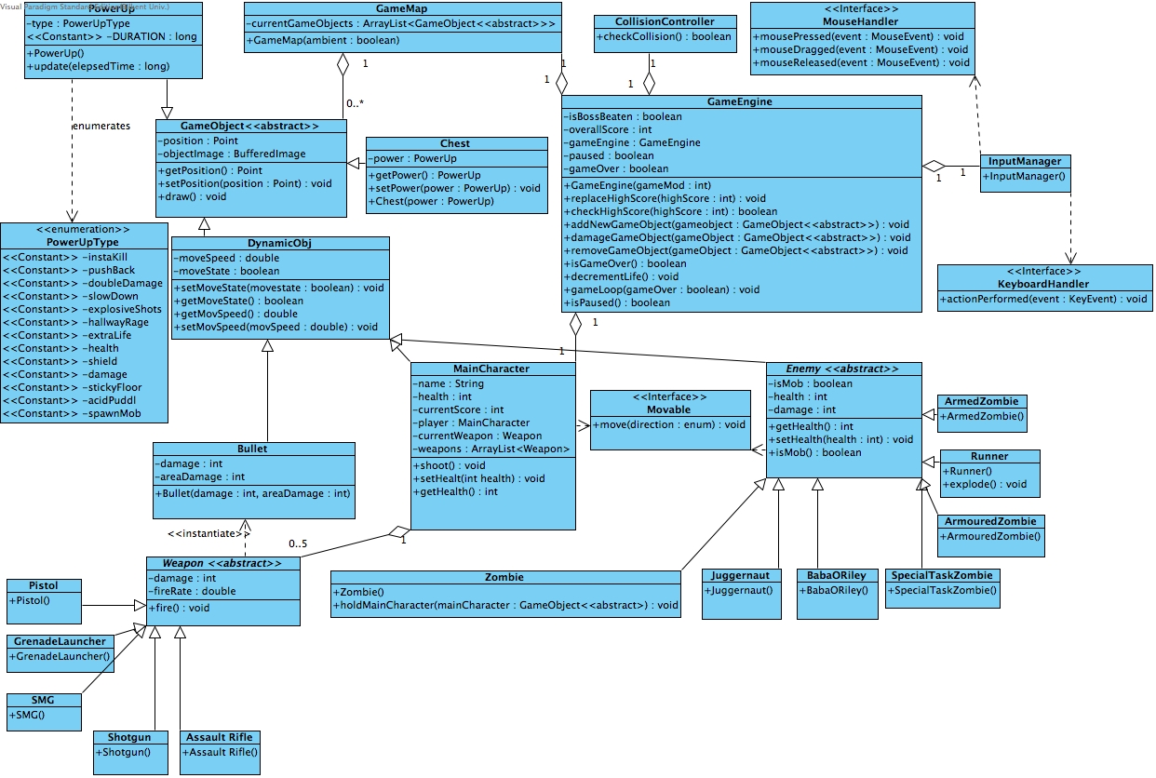
GameEngine Class
GameEngine is the class responsible from the game mechanics and algorithms. It contains the method gameLoop() responsible from the game iteration. Since each game is unique, GameEngine is a singleton class.
Attributes:
isBossBeaten:boolean : isBossBeaten is a Boolean attribute which determines if the player’s score should be stored with a gold medal status.
overallScore: int : This integer attribute represents the points scored in the game.
gameEngine:GameEngine : The instance responsible from the singleton property of the game engine.
paused:boolean: The boolean variable which determines if the game is paused.
gameOver: The boolean variable which determines if the game is over.

Methods:

GameEngine(gameMod:int): The constructor of the game engine takes gameMod as a parameter which defines the game mod. gameMod parameter is passed according to the settings.
replaceHighScore(highScore : int) : void : If the score of the player is among the best 10 scores on the board, this method replaces the score with the lowest score on the board. If the boss is beaten it adds a gold medal to the score.

checkHighScore(highScore : int) : boolean : Checks if the score is a high score.
addNewGameObject(gameObject : GameObject<<abstract>>) : void : Adds the object in the parameter to the game objects list in the GameMap instance.
damageGameObject(gameObject : GameObject<<abstract>>) : void : Decrements the health of the parameter.
removeGameObject(gameObject : GameObject<<abstract>>) : void : Removes the target from the GameMap instance.
isGameOver() : boolean : Returns gameOver attribute
decrementLife() : void : Decrements player life count by one
gameLoop(gameOver:boolean) : Takes gameOver attribute as parameter and iterates the game with the current status
isPaused() : boolean : Returns paused attribute

GameMap Class
GameMap class is responsible from keeping all the game objects in its body. It is in constant communication with the GameEngine.
Attributes:
currentGameObjects : ArrayList<GameObject<<abstract>>> : List of the game objects present in the map a certain moment.
ambient : boolean : Determines whether is day or not.
Methods:
GameMap(ambient : boolean) : It constructs a GameMap instance with the given ambient option

GameObject<<abstract>> Class

This abstract class could be considered as the parental class of most entity objects in the game.
Attributes:
position : Point : The coordinates of the object on the GameMap
objectImage : BufferedImage : The image file of the game object.

Methods:
draw() : void : Draws the graphic on the map

DynamicObj Class
This class is the parent class for all the moving objects.

Attributes:
moveSpeed : double : Determines the moving speed of the moving objects
moveState : boolean : Represents if the object is freezed or not
Methods(getters and setters)

MainCharacter Class

This is the class which the player will control. Since there is one and only player, this class is singleton.
Attributes:
name : String : Name of the player
health : int : Remaining points of health
currentScore : int : Player’s score
player : MainCharacter : The one and only instance of the singleton
currentWeapon : Weapon : The weapon used by the player
weapons : ArrayList<Weapon> : Weapons player has
Methods:
shoot() : void : Triggers the current weapon’s fire() method

Weapon<<abstract>>

The parent class of weapon classes. The weapons will differ in damage and area damage. This damage and area damage values will be determined at implementation time.
Attributes:

damage : int : The amount of damage the weapon will impact
areaDamage : int : The amount of area damage the weapon will impact
fireRate : double : The rate of fire

Methods:
fire() : void : The method which creates a bullet with the weapon’s damage and area damage.

Bullet
The bullet class has a constructor which initiates a bullet object with the damage and areadamage values passed by the weapon firing the bullet.

Enemy<<abstract>>
The class which is the parent of all the enemies in the game.
Attributes:
isMob : boolean : Represents if an enemy is a mob ( a mob and a non-mob are affected differently by the powerups)
health : int : Remaining health
damage : int : Amount of damage that the unit impacts on the player
Methods:
isMob() : boolean : returns isMob attribute
Important sub-class methods:
Zombie.holdMainCharacter(mainCharacter : GameObject<<abstract>) : void : Makes the player unable to move on collision
Runner.explode() : void : Impacts area damage on explosion point

PowerUp Class
The class representing bonuses. The type of the power-up is determined by the enumeration PowerUpType as in the class diagram.
Attributes:
type : PowerUpType : The type of the power up.
<<Constant>> DURATION : long : Duration of the powerup.

Methods:
update(elapsedTime : long) : Reduces the elapsed time from duration

Chest
The chest class which is a static object. It has a single power-up in itself (power : PowerUp).

InputManager
This class implements the handler interfaces in order to manage user inputs and communicates with the GameEngine Façade class.
CollisionController
Checks the collisions
Methods:
checkCollision(GameObject obj1, GameObject obj2) : boolean : Checks the collision and returns true if obj1 and obj2 collide.
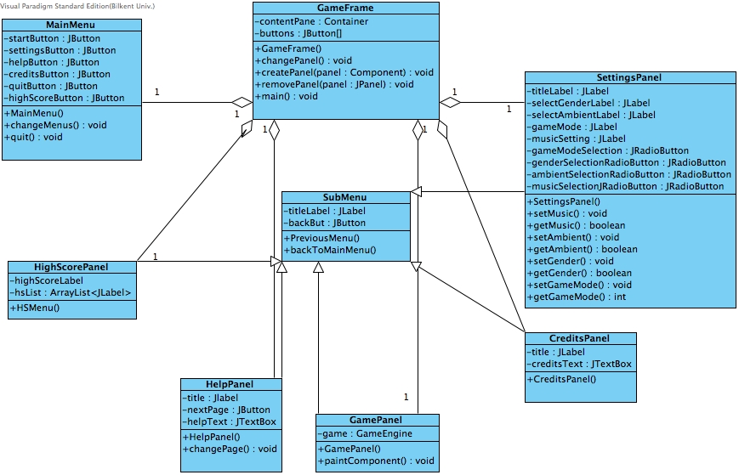

GUI Design

Hallway Rush will use Java’s Swing library as GUI components. (javax.swing library).

GameFrame: GameFrame class is an extension of JFrame class, which is included in Java’s swing library. Gameframe is the main windows where all other GUI components are settled in it.

ContentPane: ContentPane is the container of JPanels, which has ability to paint components.
JButtons: JButtons are for the changing the JPanels with the corresponding change Panel(), createPanel(), removePanel() methods.
main(): method is also included in GameFrame class therefore when the frame is closed game will run the quit method and game will stop.

MainMenu: class is an extension of JPanel class, which is included in Java’s swing library. MainMenu panel shows JButtons to the user and allows him to navigate through submenus of the game or start the game. changeMenu() method is a way pointer to which menu panel will be come to GameFrame when according JButton clicked.

HighScorePanel :HighScorePanel class is an extension of JPanel class, which is included in Java’s swing library. HighScorePanel is where user can check out highest score achieved in the game by users. 10 users can enter the highscore list.

HelpPanel : HelpPanel class is an extension of JPanel class, which is included in Java’s swing library. HelpPanel will give information to the player about gameplay and controls of the game.
Information granted through JTextBox named helpText.
There is a nextPage, button which calls for the next part of the JTextBox
GamePanel

GamePanel class is an extension of JPanel class, which is included in Java’s swing library. GamePanel class is the class where the actual gameplay happens.

Attributes
Game: gameEngine instance whichi works simultaneously with JPanel to draw objects to correct positions on screen

Methods
PaintComponent: method that uses Java’s ability to draw lines and images on screen

CreditsPanel CreditsPanelclass is an extension of JPanel class, which is included in Java’s swing library. CreditPanels is for showing users an information about developers of the HallwayRush

SettingsPanel: class is a class, which extends JPanel. This Class represents the setting menu explained in the analysis report. From the diagram it can be seen all the GUI components which allow the user the determine the settings (See analysis report for settings). Some of the settings are directly passed to game core objects' constructors.
SubMenu: This is the class for all the non-main menu panels. It has a JButton which allows to go back to the main menu. All the non-main menu panels extend this class.

Class Interfaces
MouseHandler

Handles the mouse events ( pressed, dragged, released).

KeyboardHandler

Interprets the key pressed by the user and handles it with actionPerformed(event: KeyEvent) : void method

Movable

It grants the motion of the dynamic objects by letting them implement its move(direction : enum) : void method.

Glossary & references

Wikipedia contributors. "HUD (video gaming)." Wikipedia, The Free Encyclopedia. Wikipedia, The Free Encyclopedia, 13 Nov. 2014. Web. 14 Nov. 2014.
Wikipedia contributors. "Java (programming language)." Wikipedia, The Free Encyclopedia. Wikipedia, The Free Encyclopedia, 10 Nov. 2014. Web. 13 Nov. 2014.
Object-oriented Software Engineering: Using UML, Patterns and Java. 2nd ed. Upper Saddle River, NJ: Prentice Hall, 2003. 291. Print.

Wikipedia contributors. "HUD (video gaming)." Wikipedia, The Free Encyclopedia. Wikipedia, The Free Encyclopedia, 13 Nov. 2014. Web. 14 Nov. 2014.
Wikipedia contributors. "Java (programming language)." Wikipedia, The Free Encyclopedia. Wikipedia, The Free Encyclopedia, 10 Nov. 2014. Web. 13 Nov. 2014.
Object-oriented Software Engineering: Using UML, Patterns and Java. 2nd ed. Upper Saddle River, NJ: Prentice Hall, 2003. 291. Print.

